ASSESSMENT OF GENERALIZED ANXIETY DISORDER AND COMMUNITY-BASED INTERVENTIONS

Manishiwe

# Social Demographics

|  |  |  |  |  |  |
| --- | --- | --- | --- | --- | --- |
| **Age** | | | | | |
|  | | Frequency | Percent | Valid Percent | Cumulative Percent |
| Valid | 18 - 24 years | 32 | 18.8 | 18.8 | 18.8 |
| 25 - 31 years | 60 | 35.3 | 35.3 | 54.1 |
| 32-38 years | 44 | 25.9 | 25.9 | 80.0 |
| 39 - 45 years | 25 | 14.7 | 14.7 | 94.7 |
| Above 45 years | 9 | 5.3 | 5.3 | 100.0 |
| Total | 170 | 100.0 | 100.0 |  |

|  |  |  |  |  |  |
| --- | --- | --- | --- | --- | --- |
| **Gender** | | | | | |
|  | | Frequency | Percent | Valid Percent | Cumulative Percent |
| Valid | Female | 105 | 61.8 | 61.8 | 61.8 |
| Male | 65 | 38.2 | 38.2 | 100.0 |
| Total | 170 | 100.0 | 100.0 |  |

|  |  |  |  |  |  |
| --- | --- | --- | --- | --- | --- |
| **Marital status** | | | | | |
|  | | Frequency | Percent | Valid Percent | Cumulative Percent |
| Valid | Married | 80 | 47.1 | 47.1 | 47.1 |
| Separated | 8 | 4.7 | 4.7 | 51.8 |
| Single | 60 | 35.3 | 35.3 | 87.1 |
| Single mother | 19 | 11.2 | 11.2 | 98.2 |
| Widowed | 3 | 1.8 | 1.8 | 100.0 |
| Total | 170 | 100.0 | 100.0 |  |

|  |  |  |  |  |  |
| --- | --- | --- | --- | --- | --- |
| **Education Level** | | | | | |
|  | | Frequency | Percent | Valid Percent | Cumulative Percent |
| Valid | No formal education | 11 | 6.5 | 6.5 | 6.5 |
| Primary | 27 | 15.9 | 15.9 | 22.4 |
| Secondary | 98 | 57.6 | 57.6 | 80.0 |
| Tertiary | 34 | 20.0 | 20.0 | 100.0 |
| Total | 170 | 100.0 | 100.0 |  |

|  |  |  |  |  |  |
| --- | --- | --- | --- | --- | --- |
| **Occupation** | | | | | |
|  | | Frequency | Percent | Valid Percent | Cumulative Percent |
| Valid | Casual worker | 57 | 33.5 | 33.5 | 33.5 |
| Employed | 19 | 11.2 | 11.2 | 44.7 |
| No income generating activity | 26 | 15.3 | 15.3 | 60.0 |
| Sel-employed | 24 | 14.1 | 14.1 | 74.1 |
| Small-scale business | 32 | 18.8 | 18.8 | 92.9 |
| Unemployed | 12 | 7.1 | 7.1 | 100.0 |
| Total | 170 | 100.0 | 100.0 |  |

|  |  |  |  |  |  |
| --- | --- | --- | --- | --- | --- |
| **Residence period** | | | | | |
|  | | Frequency | Percent | Valid Percent | Cumulative Percent |
| Valid | 2 - 5 years | 40 | 23.5 | 23.5 | 23.5 |
| 6 - 9 years | 59 | 34.7 | 34.7 | 58.2 |
| Over 10 years | 71 | 41.8 | 41.8 | 100.0 |
| Total | 170 | 100.0 | 100.0 |  |

|  |  |  |  |  |  |
| --- | --- | --- | --- | --- | --- |
| **Nationality** | | | | | |
|  | | Frequency | Percent | Valid Percent | Cumulative Percent |
| Valid | Burundian | 69 | 40.6 | 40.6 | 40.6 |
| Congolese | 35 | 20.6 | 20.6 | 61.2 |
| Rwandese | 58 | 34.1 | 34.1 | 95.3 |
| South Sudanese | 5 | 2.9 | 2.9 | 98.2 |
| Sundanese | 1 | .6 | .6 | 98.8 |
| Ugandan | 2 | 1.2 | 1.2 | 100.0 |
| Total | 170 | 100.0 | 100.0 |  |

|  |  |  |  |  |  |
| --- | --- | --- | --- | --- | --- |
| **GAD_LEVEL** | | | | | |
|  | | Frequency | Percent | Valid Percent | Cumulative Percent |
| Valid | Mild Anxiety | 108 | 63.5 | 63.5 | 63.5 |
| Minimal Anxiety | 12 | 7.1 | 7.1 | 70.6 |
| Moderate Anxiety | 48 | 28.2 | 28.2 | 98.8 |
| Severe Anxiety | 2 | 1.2 | 1.2 | 100.0 |
| Total | 170 | 100.0 | 100.0 |  |

## Age

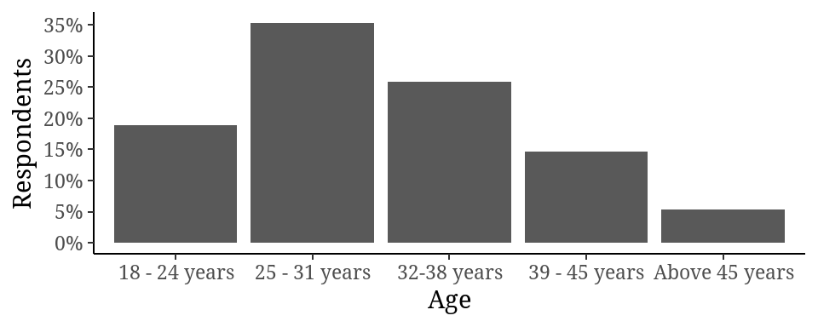

## Gender

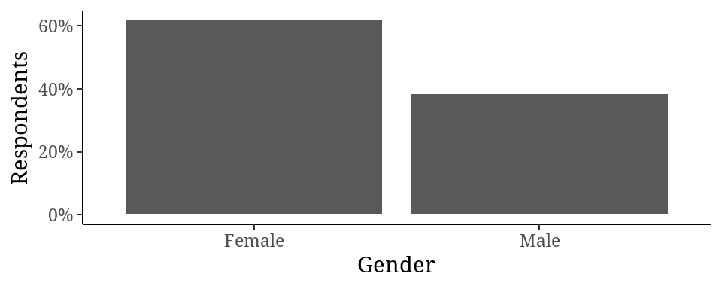

## Marital Status

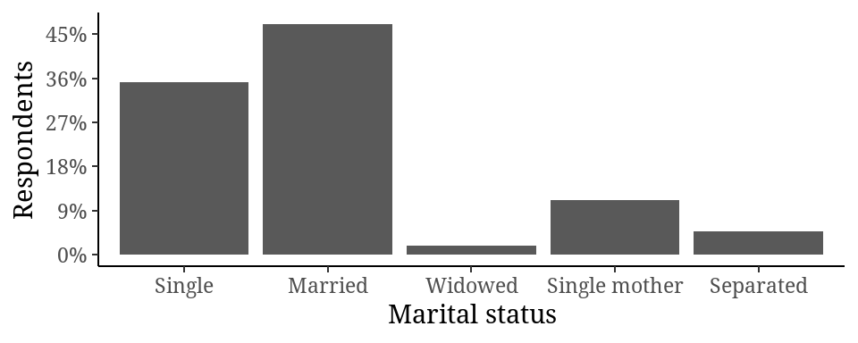

## Level of education

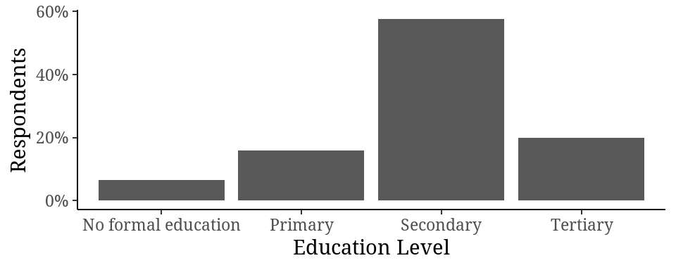

## Occupation

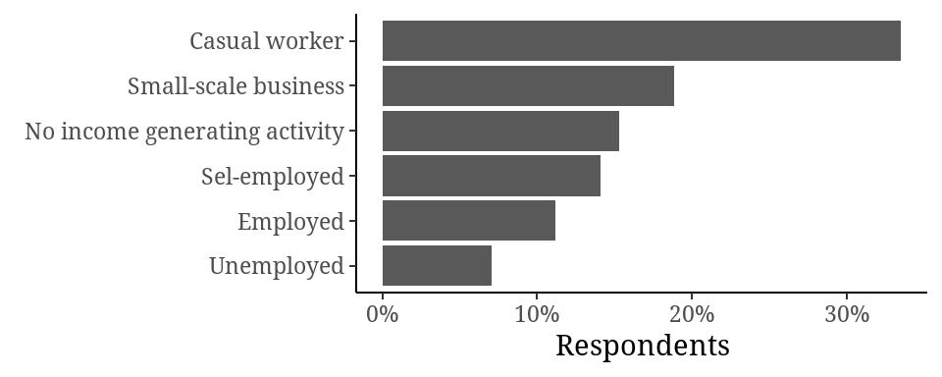

## Residence

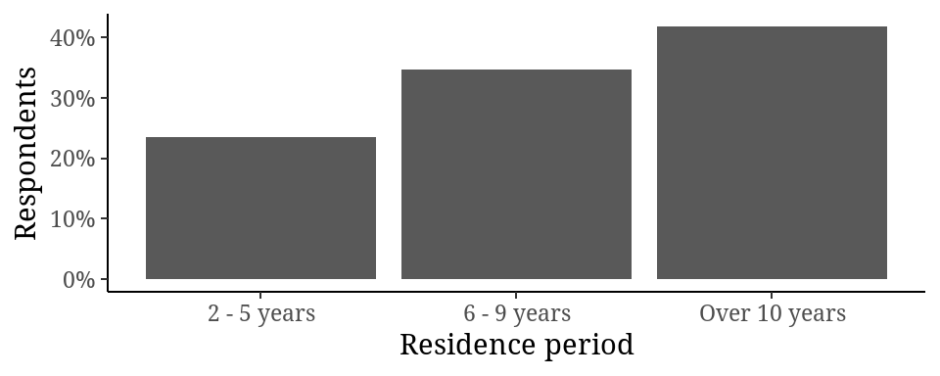

## Nationality

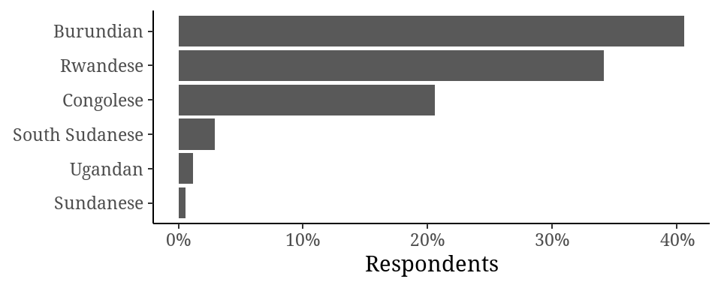

# Anxiety

## Prevalence of General Anxiety Disorder

| **Level General Anxiety Disorder** | **Prevalance of General Anxiety Disorder** |
| --- | --- |
| GAD_LEVEL |  |
| Minimal Anxiety | 12 (7.1%) |
| Mild Anxiety | 108 (64%) |
| Moderate Anxiety | 48 (28%) |
| Severe Anxiety | 2 (1.2%) |

## Preference viz

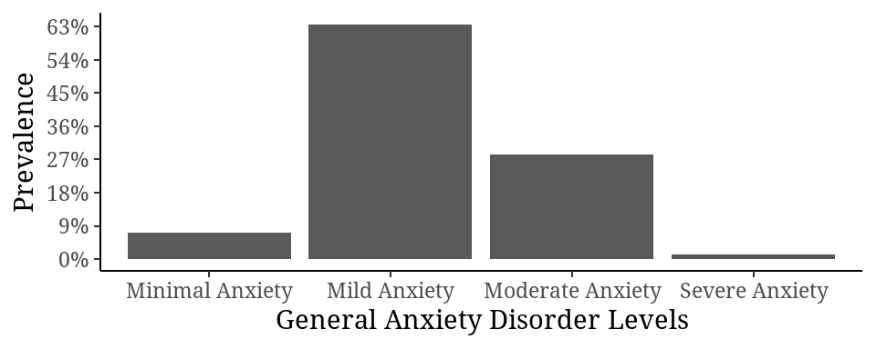

## Association between General disorder and social demographics

## Comparisons between social demographics and anxiety scores

### Age

| **Characteristic** | **18 - 24 years**, N = 32 | **25 - 31 years**, N = 60 | **32-38 years**, N = 44 | **39 - 45 years**, N = 25 | **Above 45 years**, N = 9 | **p-value** |
| --- | --- | --- | --- | --- | --- | --- |
| GAD_SCORE | 7.34 (2.70) | 8.27 (2.47) | 7.84 (3.06) | 9.04 (3.59) | 8.67 (3.94) | 0.5 |

### Gender

| **Characteristic** | **Female**, N = 105 | **Male**, N = 65 | **p-value** |
| --- | --- | --- | --- |
| GAD_SCORE | 8.33 (3.22) | 7.77 (2.43) | 0.2 |

### Marital status

| **Characteristic** | **Single**, N = 60 | **Married**, N = 80 | **Widowed**, N = 3 | **Single mother**, N = 19 | **Separated**, N = 8 | **p-value** |
| --- | --- | --- | --- | --- | --- | --- |
| GAD_SCORE | 7.33 (2.34) | 8.29 (3.08) | 7.67 (0.58) | 9.47 (3.88) | 9.25 (2.38) | 0.085 |

### Education Lecwl

| **Characteristic** | **No formal education**, N = 11 | **Primary**, N = 27 | **Secondary**, N = 98 | **Tertiary**, N = 34 | **p-value** |
| --- | --- | --- | --- | --- | --- |
| GAD_SCORE | 9.00 (1.90) | 9.07 (3.44) | 8.11 (2.52) | 7.09 (3.65) | 0.2 |

### Occupation

| **Characteristic** | **Casual worker**, N = 57 | **Employed**, N = 19 | **No income generating activity**, N = 26 | **Sel-employed**, N = 24 | **Small-scale business**, N = 32 | **Unemployed**, N = 12 | **p-value** |
| --- | --- | --- | --- | --- | --- | --- | --- |
| GAD_SCORE | 8.42 (2.67) | 6.84 (3.66) | 9.23 (2.35) | 7.33 (3.29) | 8.25 (2.20) | 7.50 (4.27) | 0.089 |

### Residence Period

| **Characteristic** | **2 - 5 years**, N = 40 | **6 - 9 years**, N = 59 | **Over 10 years**, N = 71 | **p-value** |
| --- | --- | --- | --- | --- |
| GAD_SCORE | 7.98 (2.65) | 8.19 (2.15) | 8.14 (3.63) | 0.7 |

### Nationality

| **Characteristic** | **Burundian**, N = 69 | **Congolese**, N = 35 | **Rwandese**, N = 58 | **South Sudanese**, N = 5 | **Sundanese**, N = 1 | **Ugandan**, N = 2 | **p-value** |
| --- | --- | --- | --- | --- | --- | --- | --- |
| GAD_SCORE | 8.19 (2.94) | 8.31 (2.26) | 7.91 (3.46) | 7.40 (1.52) | 9.00 (NA) | 9.50 (2.12) | 0.7 |

## Association between social demographics and anxiety

## Age

|  | Minimal Anxiety | Mild Anxiety | Moderate Anxiety | Severe Anxiety | Total |
| --- | --- | --- | --- | --- | --- |
| Age |  |  |  |  |  |
| 18 - 24 years | 4 (33%) | 20 (19%) | 8 (17%) | 0 (0%) | 32 (19%) |
| 25 - 31 years | 2 (17%) | 41 (38%) | 16 (33%) | 1 (50%) | 60 (35%) |
| 32-38 years | 4 (33%) | 30 (28%) | 10 (21%) | 0 (0%) | 44 (26%) |
| 39 - 45 years | 1 (8.3%) | 13 (12%) | 10 (21%) | 1 (50%) | 25 (15%) |
| Above 45 years | 1 (8.3%) | 4 (3.7%) | 4 (8.3%) | 0 (0%) | 9 (5.3%) |
| Total | 12 (100%) | 108 (100%) | 48 (100%) | 2 (100%) | 170 (100%) |

## Gender

|  | Minimal Anxiety | Mild Anxiety | Moderate Anxiety | Severe Anxiety | Total |
| --- | --- | --- | --- | --- | --- |
| Gender |  |  |  |  |  |
| Female | 9 (75%) | 61 (56%) | 33 (69%) | 2 (100%) | 105 (62%) |
| Male | 3 (25%) | 47 (44%) | 15 (31%) | 0 (0%) | 65 (38%) |
| Total | 12 (100%) | 108 (100%) | 48 (100%) | 2 (100%) | 170 (100%) |

## Marital status

|  | Minimal Anxiety | Mild Anxiety | Moderate Anxiety | Severe Anxiety | Total |
| --- | --- | --- | --- | --- | --- |
| Marital status |  |  |  |  |  |
| Single | 5 (42%) | 44 (41%) | 11 (23%) | 0 (0%) | 60 (35%) |
| Married | 6 (50%) | 45 (42%) | 28 (58%) | 1 (50%) | 80 (47%) |
| Widowed | 0 (0%) | 3 (2.8%) | 0 (0%) | 0 (0%) | 3 (1.8%) |
| Single mother | 1 (8.3%) | 11 (10%) | 6 (13%) | 1 (50%) | 19 (11%) |
| Separated | 0 (0%) | 5 (4.6%) | 3 (6.3%) | 0 (0%) | 8 (4.7%) |
| Total | 12 (100%) | 108 (100%) | 48 (100%) | 2 (100%) | 170 (100%) |

## Education level

|  | Minimal Anxiety | Mild Anxiety | Moderate Anxiety | Severe Anxiety | Total |
| --- | --- | --- | --- | --- | --- |
| Education Level |  |  |  |  |  |
| No formal education | 0 (0%) | 8 (7.4%) | 3 (6.3%) | 0 (0%) | 11 (6.5%) |
| Primary | 1 (8.3%) | 16 (15%) | 9 (19%) | 1 (50%) | 27 (16%) |
| Secondary | 4 (33%) | 66 (61%) | 28 (58%) | 0 (0%) | 98 (58%) |
| Tertiary | 7 (58%) | 18 (17%) | 8 (17%) | 1 (50%) | 34 (20%) |
| Total | 12 (100%) | 108 (100%) | 48 (100%) | 2 (100%) | 170 (100%) |

## Occupation

|  | Minimal Anxiety | Mild Anxiety | Moderate Anxiety | Severe Anxiety | Total |
| --- | --- | --- | --- | --- | --- |
| Occupation |  |  |  |  |  |
| Casual worker | 0 (0%) | 40 (37%) | 16 (33%) | 1 (50%) | 57 (34%) |
| Employed | 3 (25%) | 13 (12%) | 2 (4.2%) | 1 (50%) | 19 (11%) |
| No income generating activity | 0 (0%) | 16 (15%) | 10 (21%) | 0 (0%) | 26 (15%) |
| Sel-employed | 5 (42%) | 13 (12%) | 6 (13%) | 0 (0%) | 24 (14%) |
| Small-scale business | 1 (8.3%) | 21 (19%) | 10 (21%) | 0 (0%) | 32 (19%) |
| Unemployed | 3 (25%) | 5 (4.6%) | 4 (8.3%) | 0 (0%) | 12 (7.1%) |
| Total | 12 (100%) | 108 (100%) | 48 (100%) | 2 (100%) | 170 (100%) |

## Residence period

|  | Minimal Anxiety | Mild Anxiety | Moderate Anxiety | Severe Anxiety | Total |
| --- | --- | --- | --- | --- | --- |
| Residence period |  |  |  |  |  |
| 2 - 5 years | 1 (8.3%) | 28 (26%) | 11 (23%) | 0 (0%) | 40 (24%) |
| 6 - 9 years | 2 (17%) | 38 (35%) | 19 (40%) | 0 (0%) | 59 (35%) |
| Over 10 years | 9 (75%) | 42 (39%) | 18 (38%) | 2 (100%) | 71 (42%) |
| Total | 12 (100%) | 108 (100%) | 48 (100%) | 2 (100%) | 170 (100%) |

## Nationality

|  | Minimal Anxiety | Mild Anxiety | Moderate Anxiety | Severe Anxiety | Total |
| --- | --- | --- | --- | --- | --- |
| Nationality |  |  |  |  |  |
| Burundian | 5 (42%) | 40 (37%) | 24 (50%) | 0 (0%) | 69 (41%) |
| Congolese | 0 (0%) | 25 (23%) | 10 (21%) | 0 (0%) | 35 (21%) |
| Rwandese | 7 (58%) | 37 (34%) | 12 (25%) | 2 (100%) | 58 (34%) |
| South Sudanese | 0 (0%) | 4 (3.7%) | 1 (2.1%) | 0 (0%) | 5 (2.9%) |
| Sundanese | 0 (0%) | 1 (0.9%) | 0 (0%) | 0 (0%) | 1 (0.6%) |
| Ugandan | 0 (0%) | 1 (0.9%) | 1 (2.1%) | 0 (0%) | 2 (1.2%) |
| Total | 12 (100%) | 108 (100%) | 48 (100%) | 2 (100%) | 170 (100%) |

## Pie charts

### Age

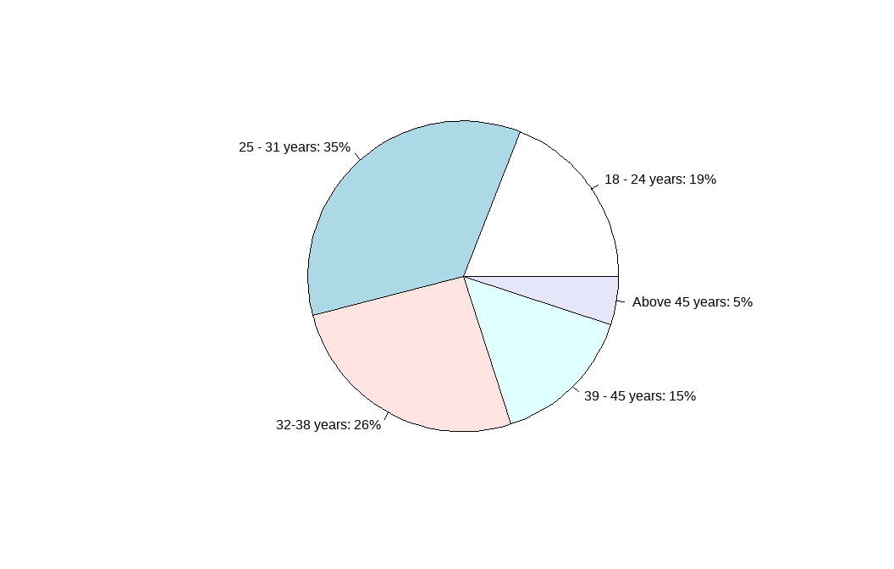

### Gender

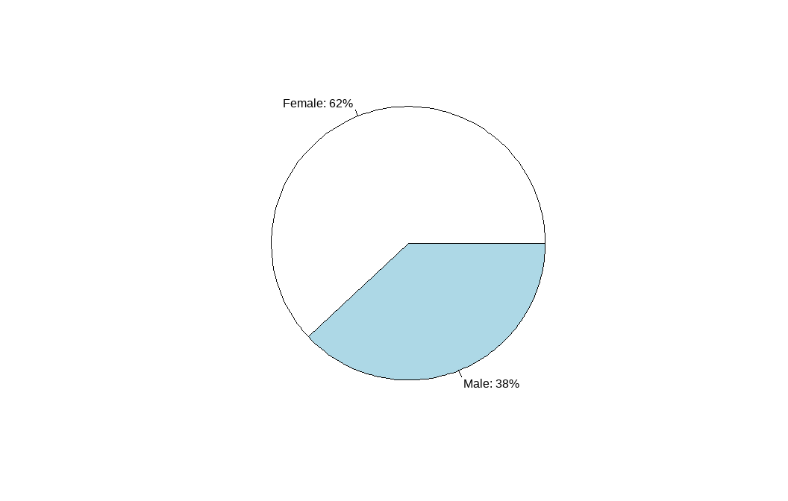

### Marital Status

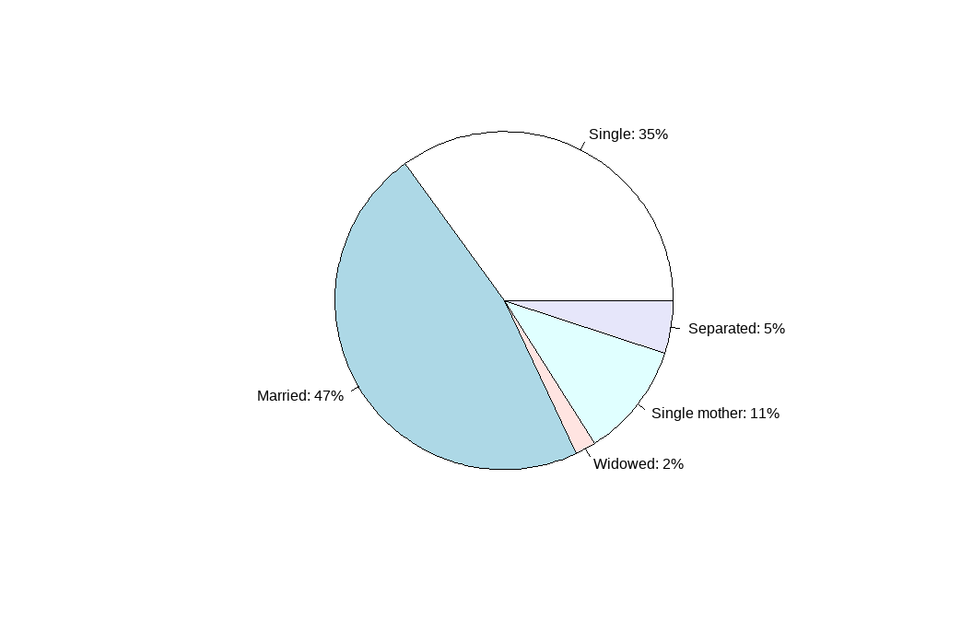

### Education Level

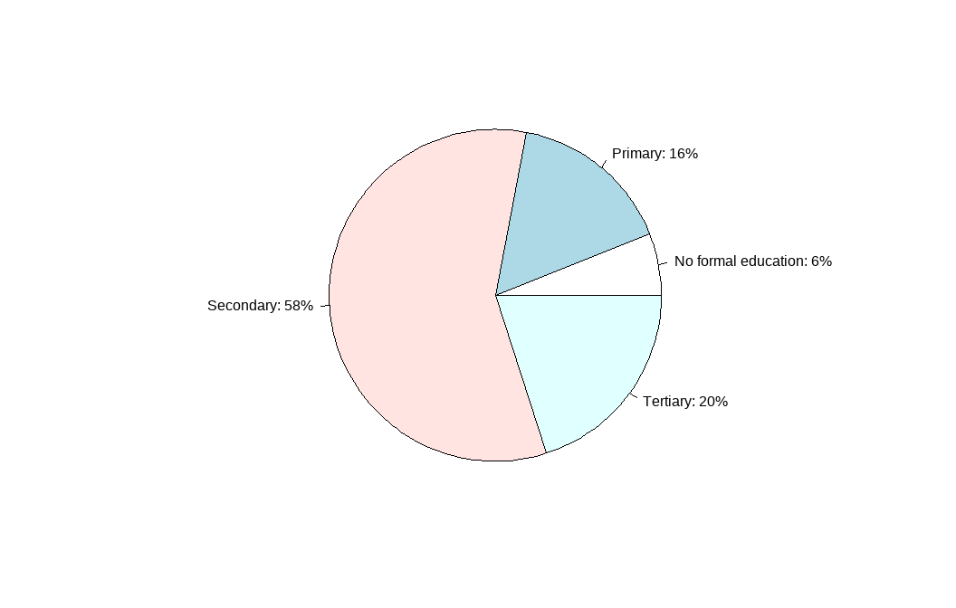

### Occupation

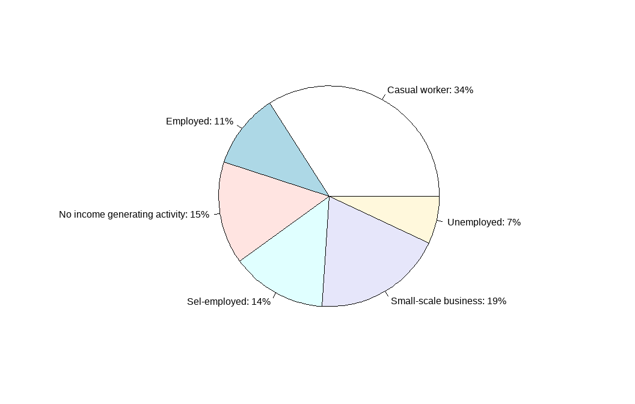

### Residence period

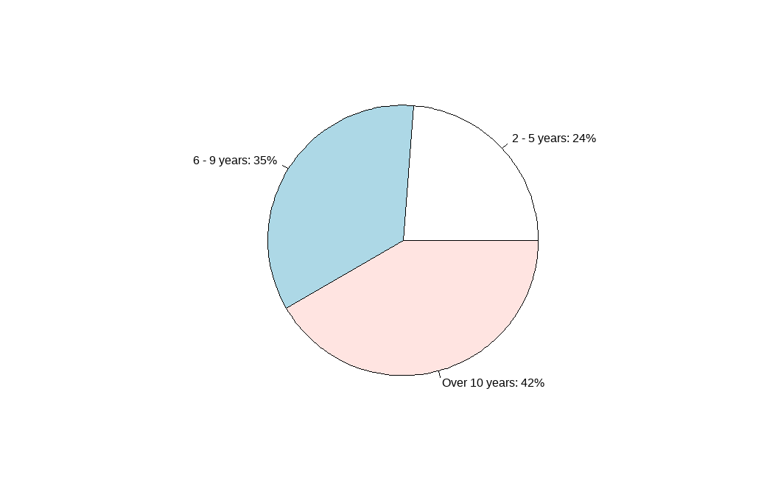

### Nationality

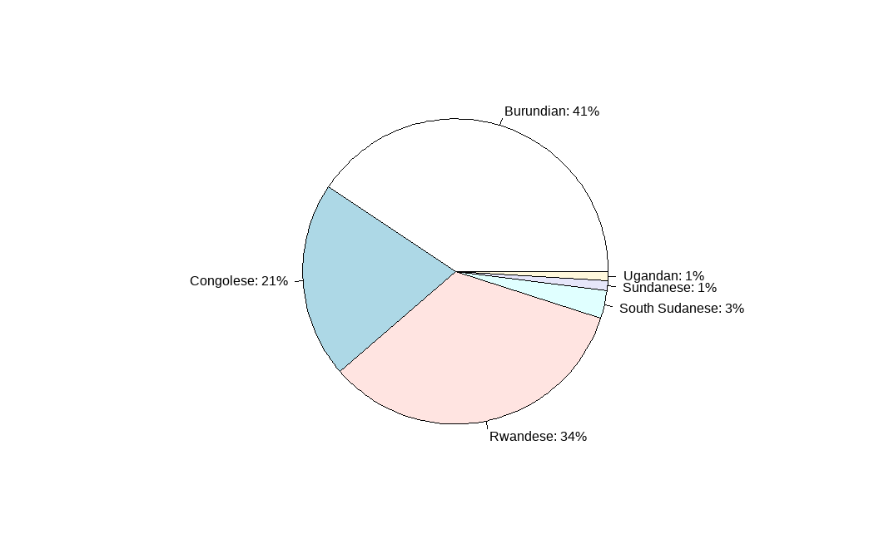

### Anxiety

